***INTRODUCTION***

* 1. ***OVERVIEW***

***Human resources managers are leaders with in HR departments, overseeing the functions of an organization that takes care of its workers. The role can very depending on where you work, but many of the core responsibilities are consistent across organizations.***

***Human Resource management (HRM) is the strategic and coherent approach to the effective and efficient management of people in a company or organization such that they help their business gain a competitive advantage. It is designed to maximize employee performance in service of an employee strategic objectives. HRM is an recruiting, hiring, deploying, managing an organization employees.***

***To use human resources as effectively as possible. To ensure the best possible working relationships among all members of the organization. To assist individuals to reach their highest potential.***

* 1. ***PURPOSE:***

***Purpose of HR***

***The Purpose of to maximize the productivity of an organization by optimizing the effectiveness of its employee. This mandate is unlikely to change in any fundamental way, despite the ever increasing pace of change in the business world.***

***Help the organization achieve its goals by providing and maintaining productive employees. Efficiently make use of the skills and abilities of each employee. Make sure employee have or receive the proper training.***

***HRM basics function: staffing, training and development, motivation, maintenance***

***PROBLEM DEFINITION AND DESIGN THINKING***

***2.1 EMPATHY MAP***

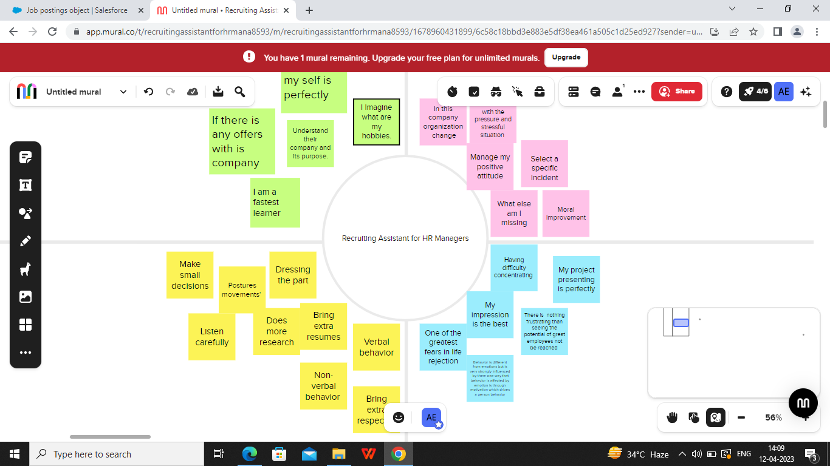

***2.2 IDEATION AND BRAIN STORMING MAP***

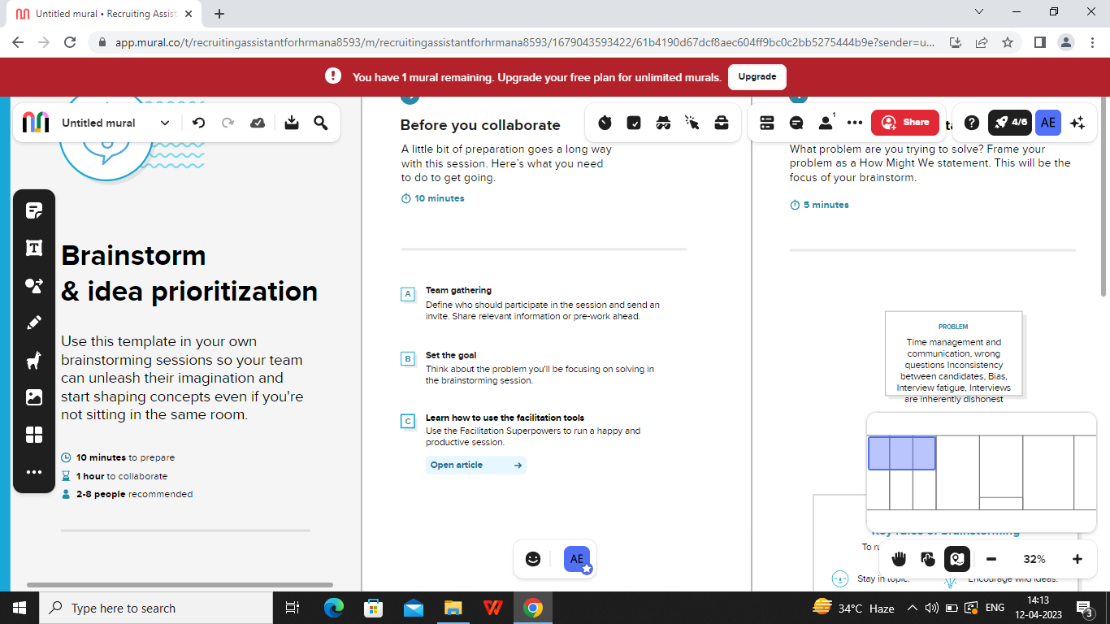

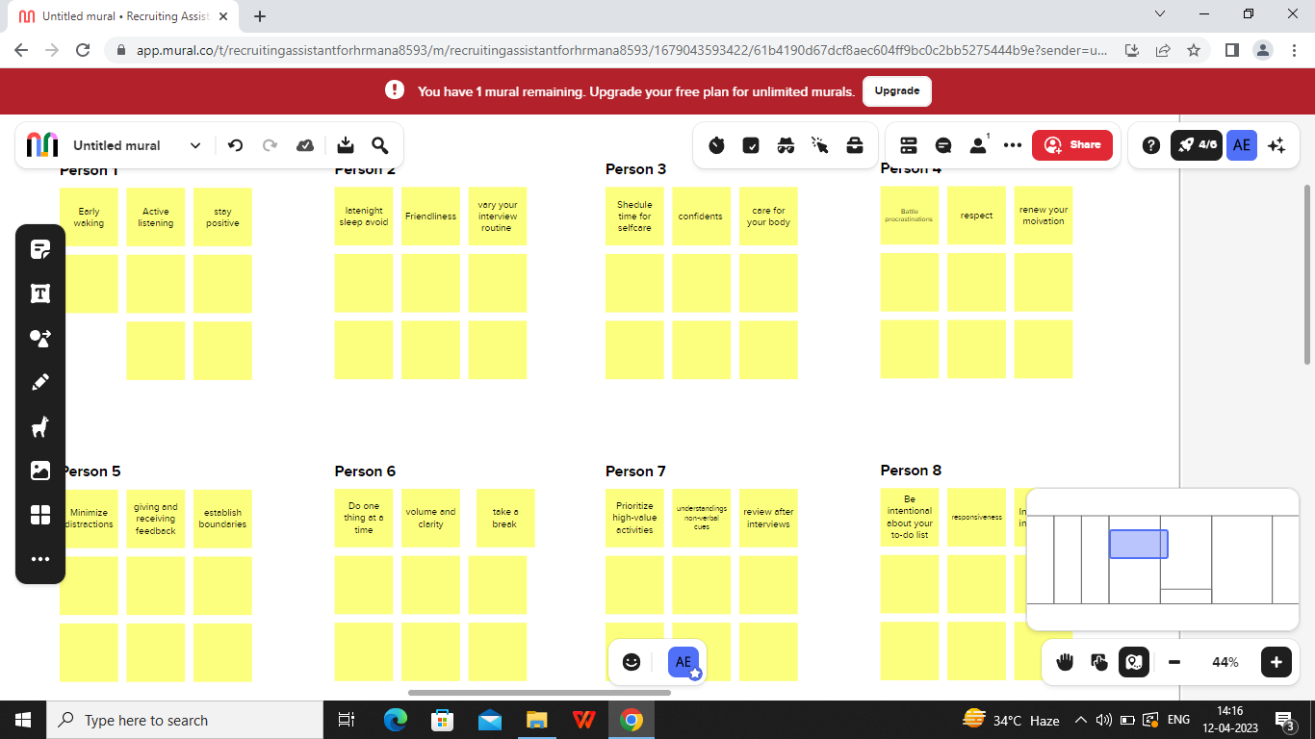

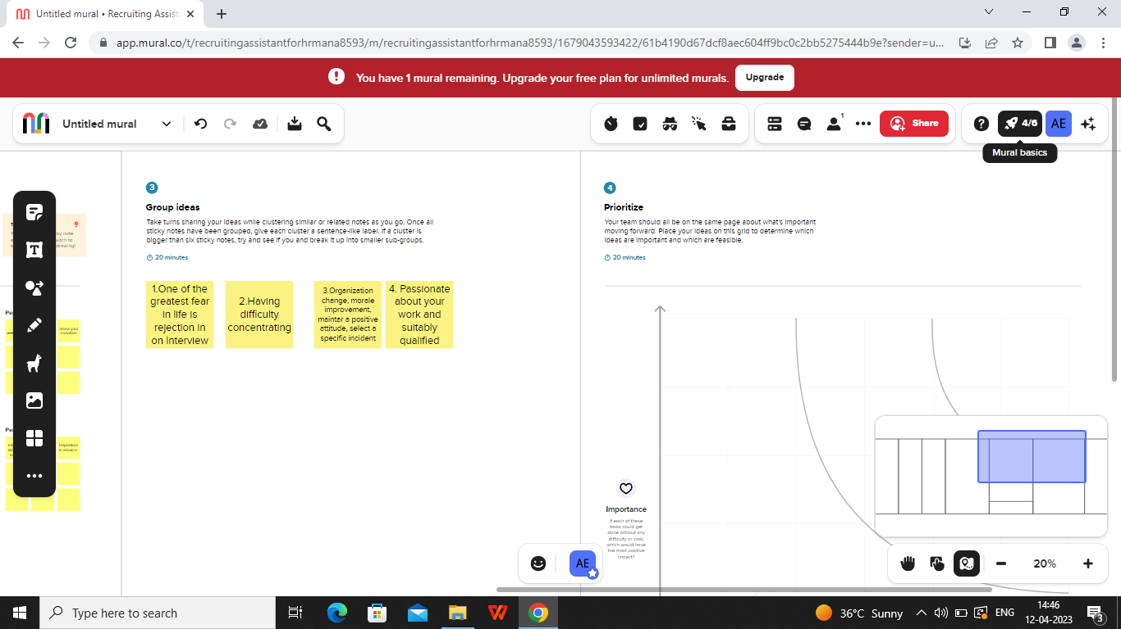

***RESULT***

***3.1 DATA MODEL***

|  |  |  |
| --- | --- | --- |
| **Object name** | **Fields in the object** | |
| **Job posting site** | |  |  | | --- | --- | | **Field label** | **Data type** | | **Job posting site URL** | **URL** | | **Status** | **URL** | | |
| **Custom object** | |  |  | | --- | --- | | **Field label** | **Data type** | | **Job posting site** | **Text** | | **Review** | **Auto Number** | |

***3.2 ACTIVITY AND SCREENSHOT***

***Milestone 1:***

***Description for Salesforce:***

***In this Salesforce , we are going to take a look at a getting a***

***Life time free Salesforce developer account . So we can created the***

***Salesforce Developer Org get started.***

***The Screenshot are pasted below***

***Creation of developer account:***

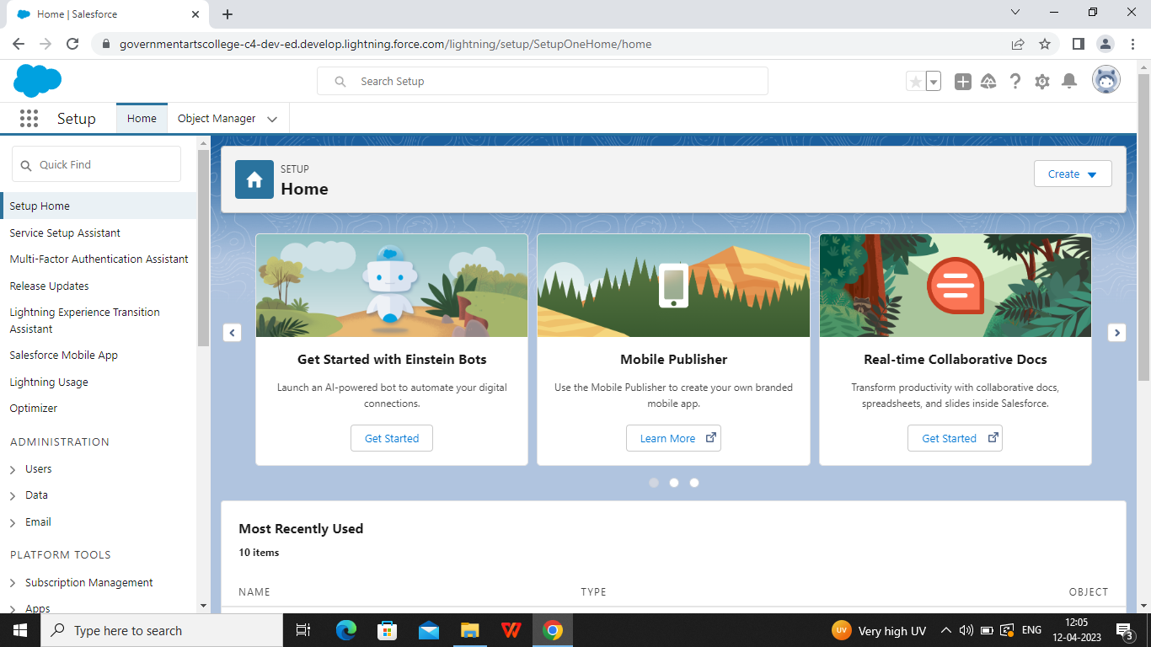

***Milestone2:***

***Description for Recruiting app package:***

***A recruitment app package covers all stages of the hiring process and helps employers and job seekers connect on an easy-to-navigate platform. These HR tools are efficient in streamlining activities and processes, resulting in improved quality. People use them to post job openings, find suitable candidates, and look for jobs.***

***In Salesforce , a package is a collection of Apex classes, Visual force pages, triggers, and other components that can be installed into an organization.***

***There are two types of package:***

***Managed and Unman aged***

***Managed packages are developed and distributed by (Independent Software Vendors) and can be installed from the Salesforce App Exchange while unman aged packages are created and distributed by Salesforce administrators within an organization. To install a package, an administrator can navigate to the App Exchange, find the desired package, and click the install button. The administrator will then be promoted to login to their Salesforce organization and provide permission to install the package.***

***The screenshot are pasted below:***

***Package Installation for Recruiting App:***

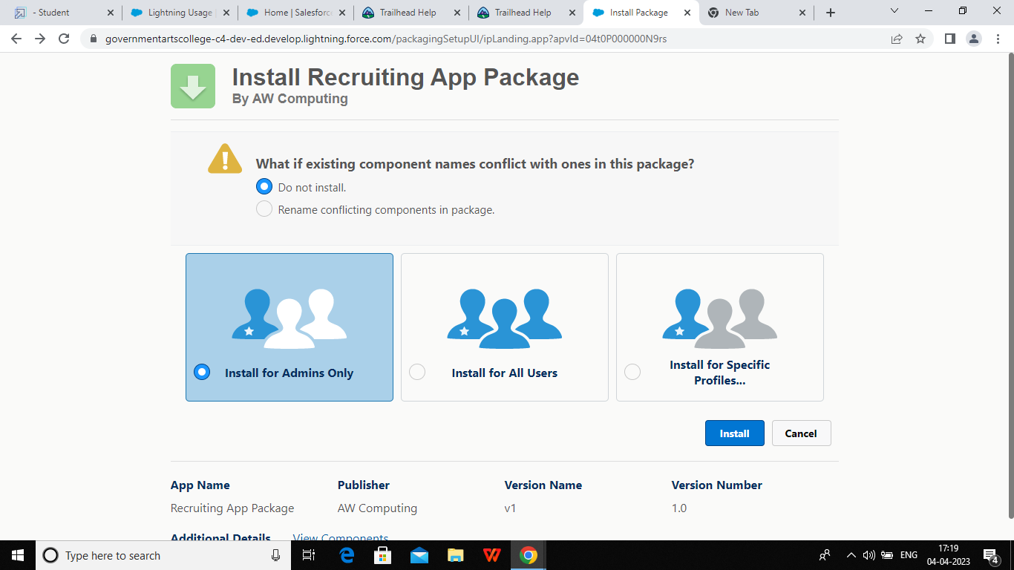

***Milestone 3:***

***Description for object:***

***Salesforce objects are database tables that permit you to store***

***Data that is specific to an organization.***

***It consists of fields (columns)and records (rows)***

***Custom object features:***

***Build page layout to control which fields users can view and edit when entering data for the custom object records.***

***Import custom objects records.***

***Track tasks and events for custom records.***

***Create reports and dashboards to analyze custom object data.***

***Salesforce object of two types:***

***Standard objects: Standard objects are the kind of objects that are provided by Salesforce.com such as users, contacts, reports, dashboards, etc.***

***Columns objects: custom objects are those objects that can be created by users. They supply information that is unique end essential to their organization. They are heart of any application and provide a structure for a sharing data.***

***The screenshots are pasted below:***

***Custom objects for Job posting sites:***

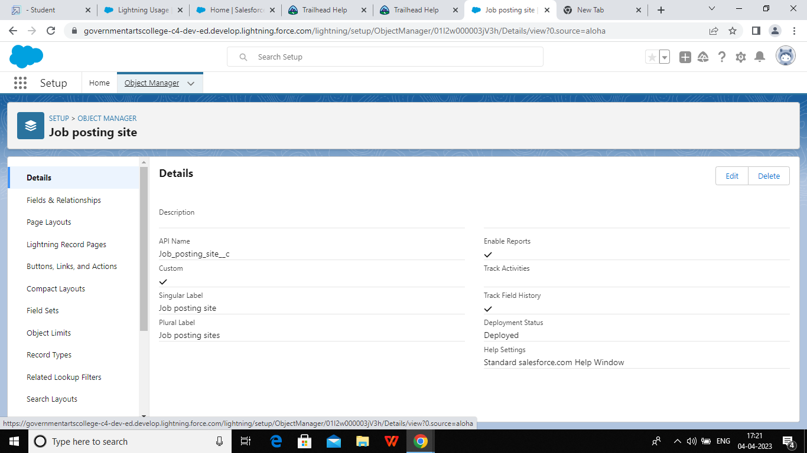

***Custom objects for Review:***

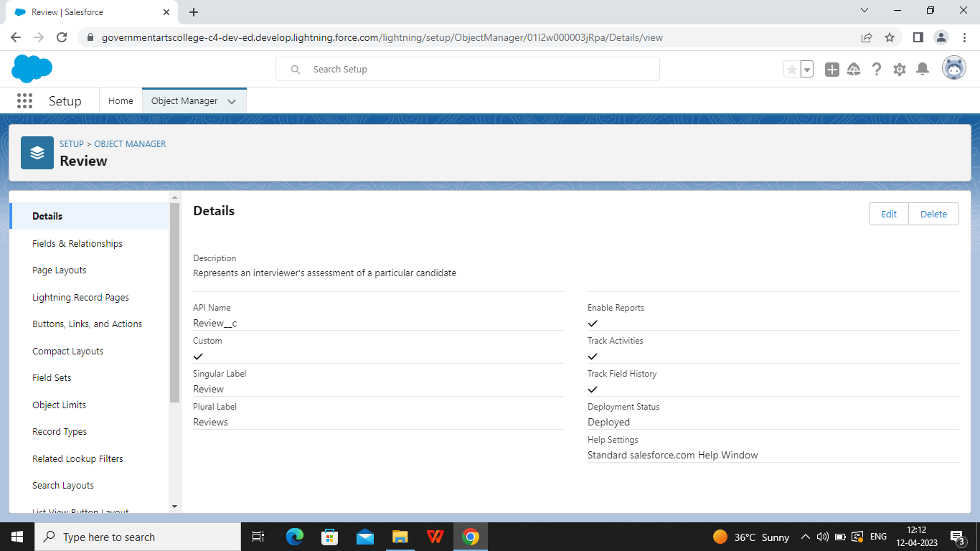

***Milestone 4***

***Description for Tabs:***

***A tab is like a user interface that is used to build records for objects and view the records in the objects.***

***“A short projecting device. Such as a small flap or loop by which something may be grasped or pulled. A projection from a card used as an aid in filling”.***

***Custom tab is a user interface components which we create we create to display custom object data or other web content embedded in the application. We can find all these three tabs in different edition of Salesforce.***

***Standard objects tabs display data related to standard objects. Custom objects tabs display data related to custom objects. Web display in any external web-based application or web page in a Salesforce.com.***

***Three different kind of custom tabs:***

1. ***Custom object tab***
2. ***Web tab***
3. ***Visual force page.***
4. ***Standard object tab***

***Difference between tabs and objects in Salesforce:***

***Tab in Salesforce is a user interface to build records for objects and view records in objects.***

***Objects are the database tables that permit us to the store data specific to the organization.***

***The screenshot are pasted in below:***

***Creating the custom tab:***

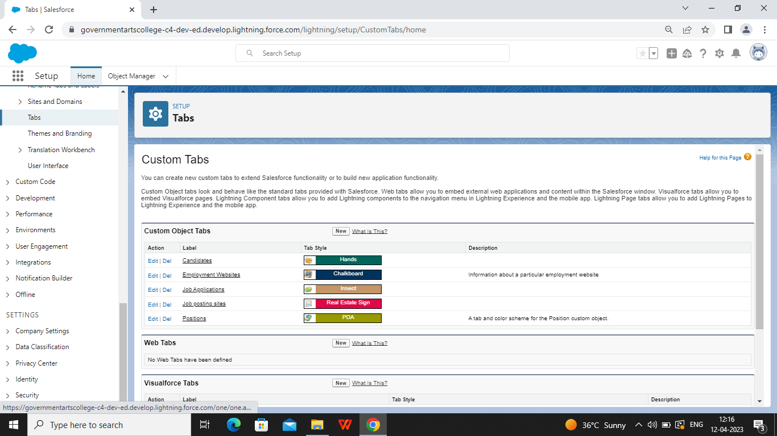

***Milestone 5***

***Description for fields:***

***Fields in Salesforce represent what the columns represent in relational databases. It can be store data values which are required for a particular object in a record.***

***There are two type in Salesforce :***

***Standard fields:There are four fields in every custom object there are created by, last modified by, owner and the field at the time of creation of an object.***

***These fields cannot be deleted or edited and they are always required.***

***For standard objects the fields which are present by default in them and cannot be deleted or edited from standard objects are standard fields.***

***Custom objects: The custom fields which are added by the administrator or developer to meet the business requirements of any organization.***

***They are or may not be required.***

***The maximum number of Custom tabs available varies edition for Salesforce Contact manager edition, Group edition, Developer edition.***

***The screenshot are pasted in below:***

***Create the new field for job posting site:***

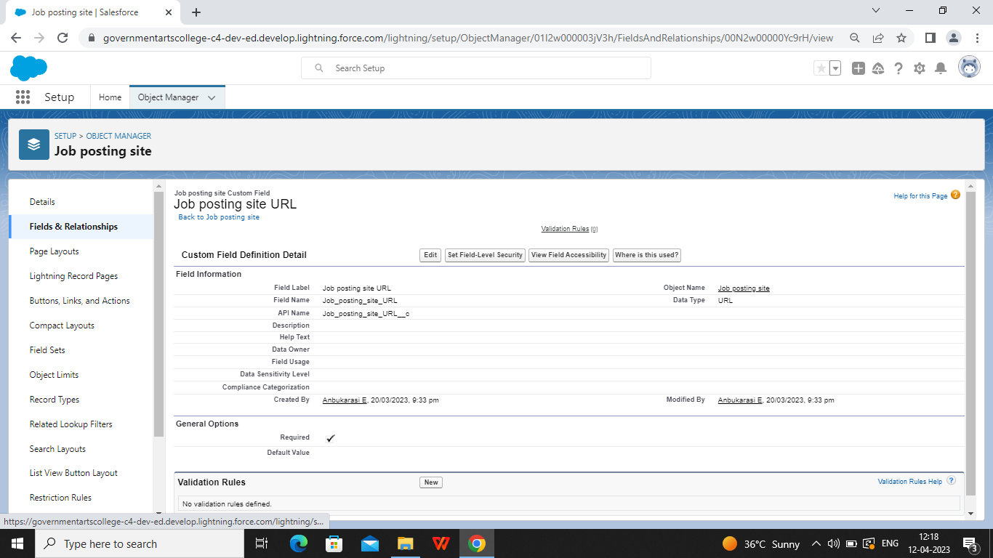

***Create the field for Status:***

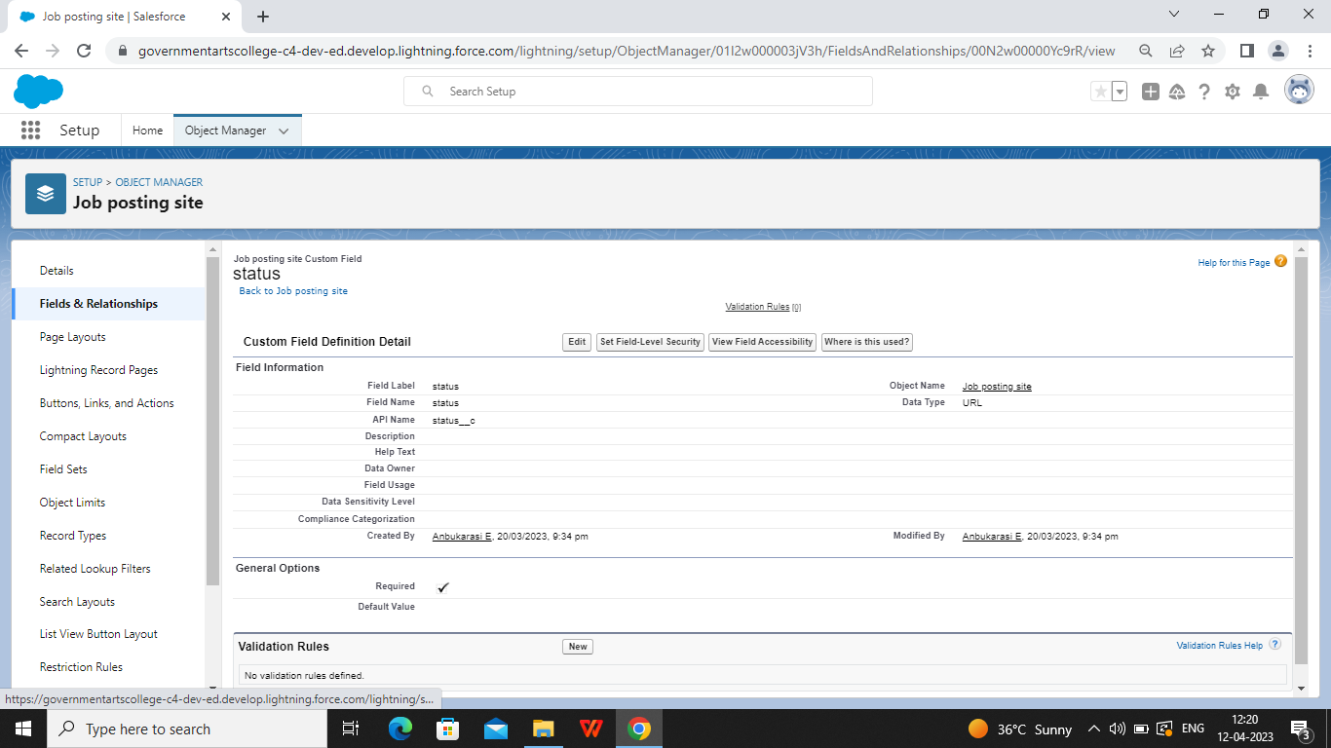

***Create the field for Technical site***

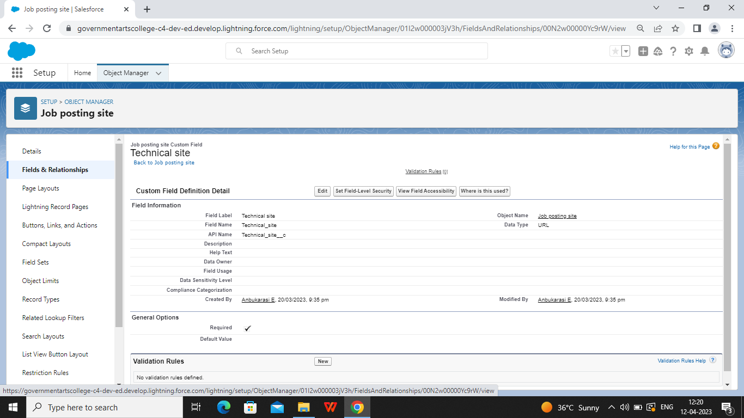

***Create the field for Description:***

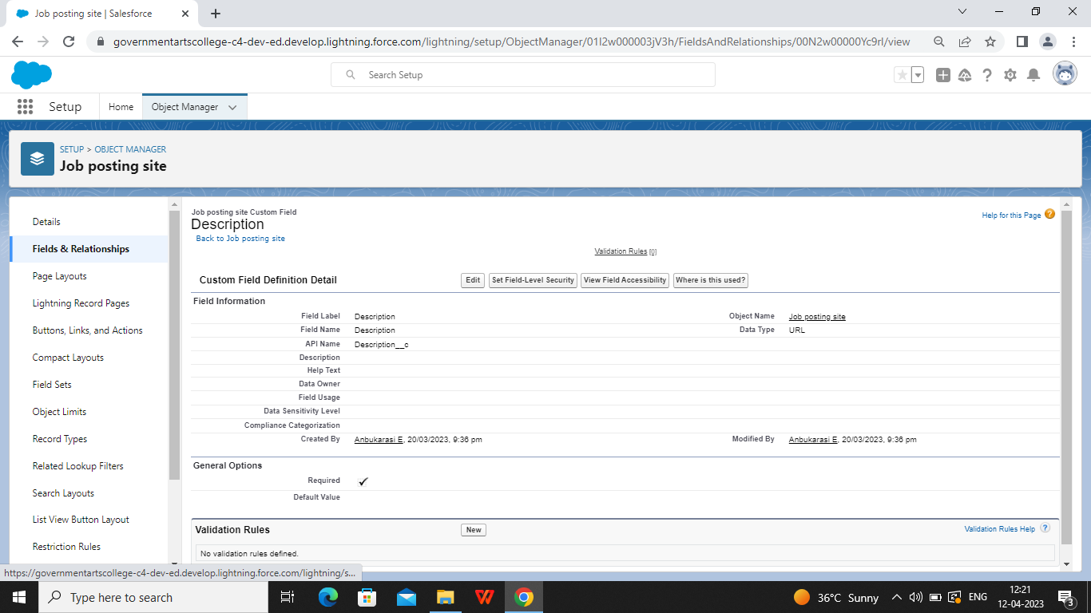

***Milestone 6:***

***Description for Junction object***

***“Junction object is a type of custom object which allows linking or custom object or one custom instance to many children records and each child can equally be liked in to many parents”.***

***HR’ recruiting app is to create a junction object is called a job posting site. A junction object is a custom object with two-master-detail relationships, and it is the key to making a many-to-many relationship. A job posting fits into the space between positions and employment websites.***

***In Salesforce, a junction object is a custom object that is used to create a many-to-many relationships between two other objects. It connects two objects together by creating two one-to-many relationships, allowing data from both objects to be associated with each other in a single record. For example, if you gave custom object for “projects” and another for “Teams”, a junction object could be used to connect individual team members, to multiple projects.***

***The screenshot are pasted below:***

***Creating a new custom object:***

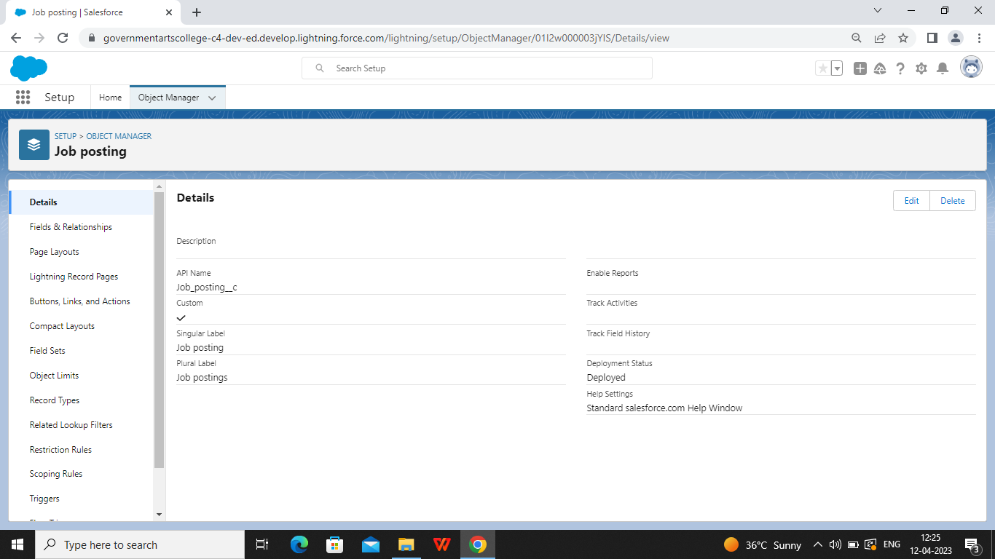

***Creating a master-detail relationship between Job posting and job posting site:***

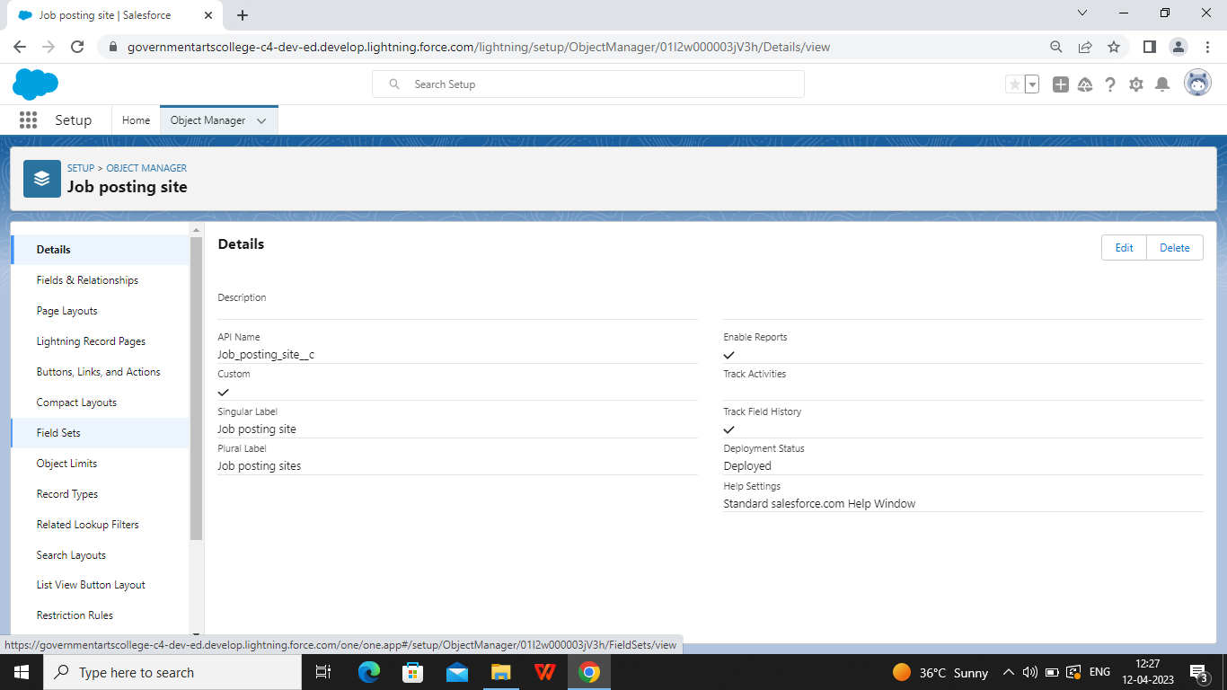

***Creating a master-detail relationship between job posting and position:***

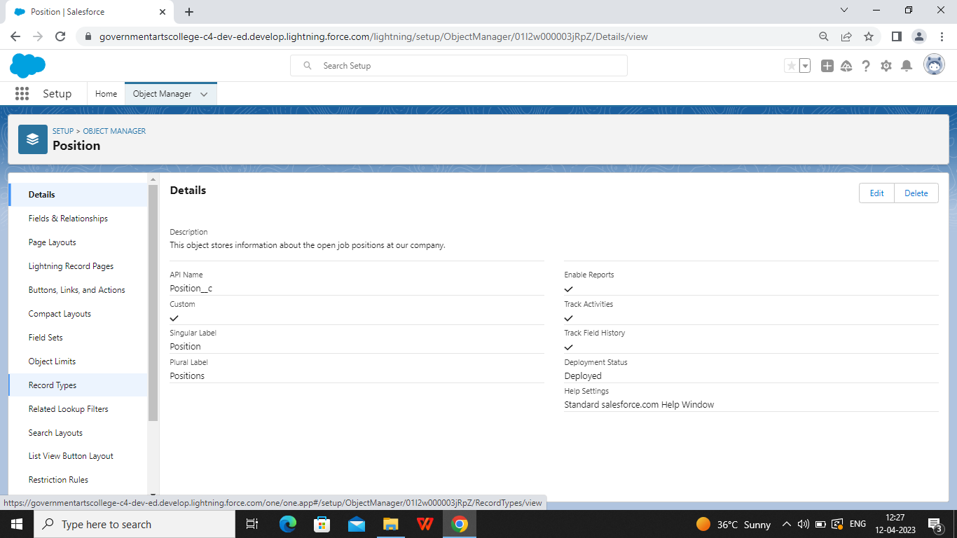

***Milestone 7***

***Description for Page layout:***

***Page layout in Salesforce allow us to customize the design and organization of detail and edit pages of records in Salesforce. Page layouts can be used to control the appearance of fields, related lists, and custom links on standard and custom object detail and edit pages.***

***In Salesforce, a page layout is a visual design of a page that determines the organization and arrangements of fields, buttons, and other components on a page. Page layout can be customized to show the fields and related information that are most relevant to different users, roles, and record types. They can be also used to control the visibility and access to fields, buttons, ad other components on a page.***

***The screenshot are pasted below:***

***Page layout for positions:***

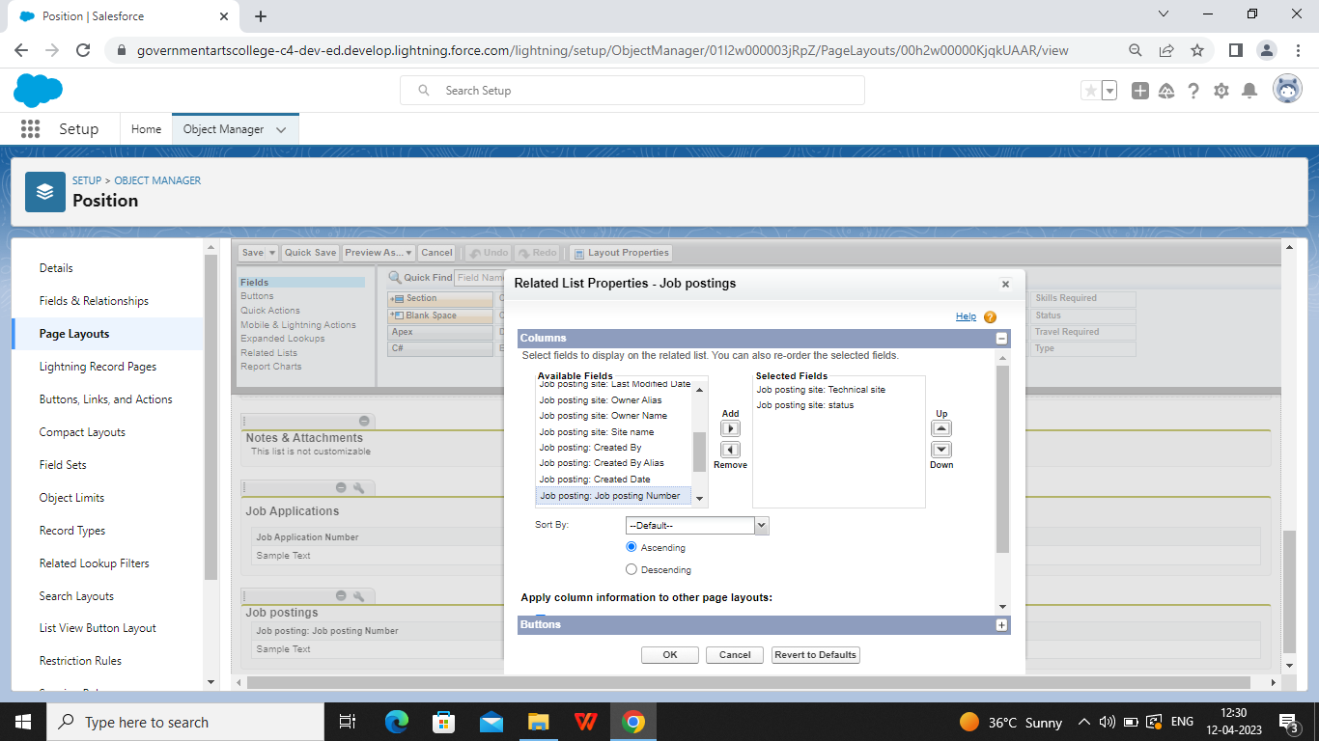

***Page layout for Review object:***

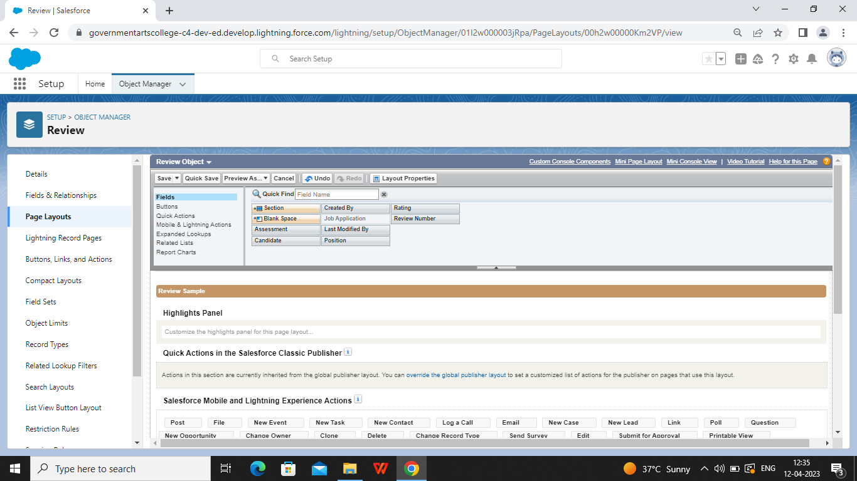

***Milestone 8:***

***Description for Validation rule:***

***A validation is a a process which checks out (candidate) the inputs given by any user is correct or not according to your requirement.***

***In a Salesforce , validation rules are used ti enforc3 certain data requirements and constraints on records, while formulas are used to perform calculations and generate values for fields record.***

***The screenshot are pasted below:***

***Phone number validation rule:***

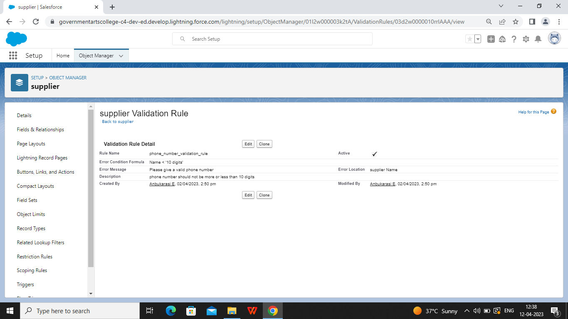

***Validation rule for Technical site checkbox is equal is true:***

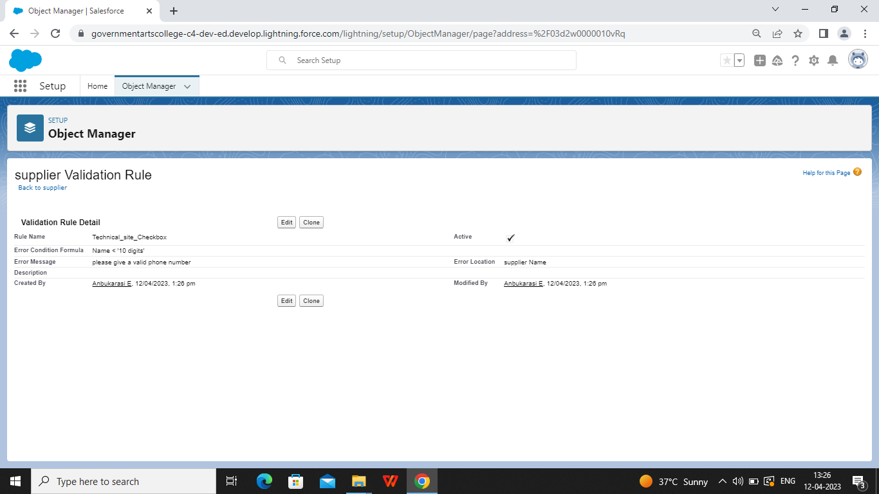

***Milestone 9***

***Description for Profile:***

***A profile is a group or collection of settings and permissions that define, what a user can do Salesforce. A profile controls Object permissions,Field permissions,User permissions, App settings, Apex class access, Visual force page access, page layout, record types, login hours, and login ranges.***

***A profile can be assigned to many users, but user can be assigned single profile at a time.***

***Here are some of the major standard profiles in Salesforce that are assigned sets of permissions and settings:***

***System Administrator, Platform one app user, platform user, user, partner , manager.***

***The screenshot are pasted below:***

***Profile for Event Profile page:***

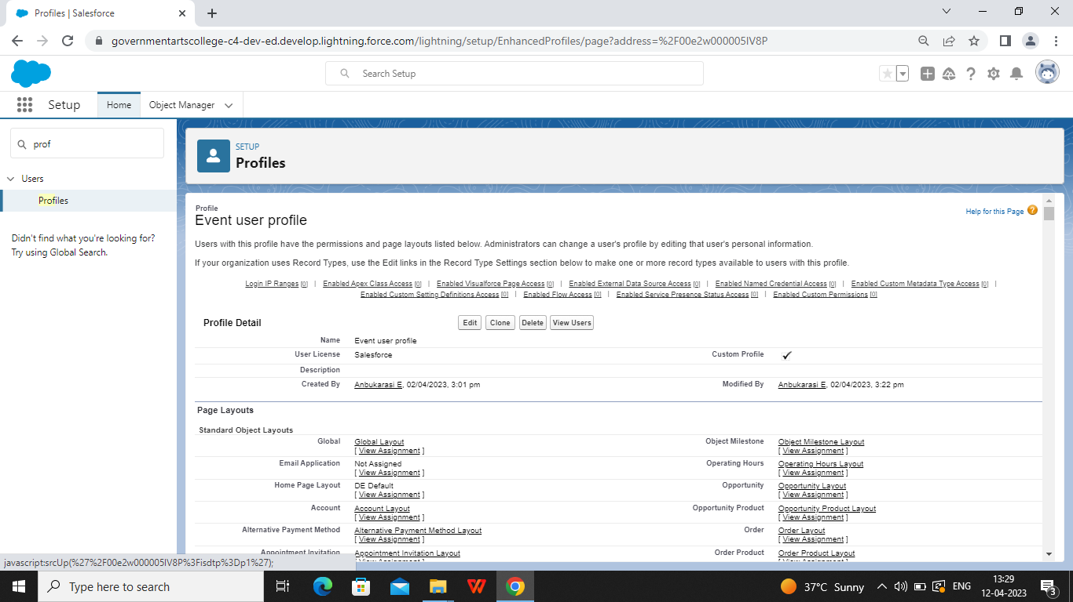

***Profile for Sales profile:***

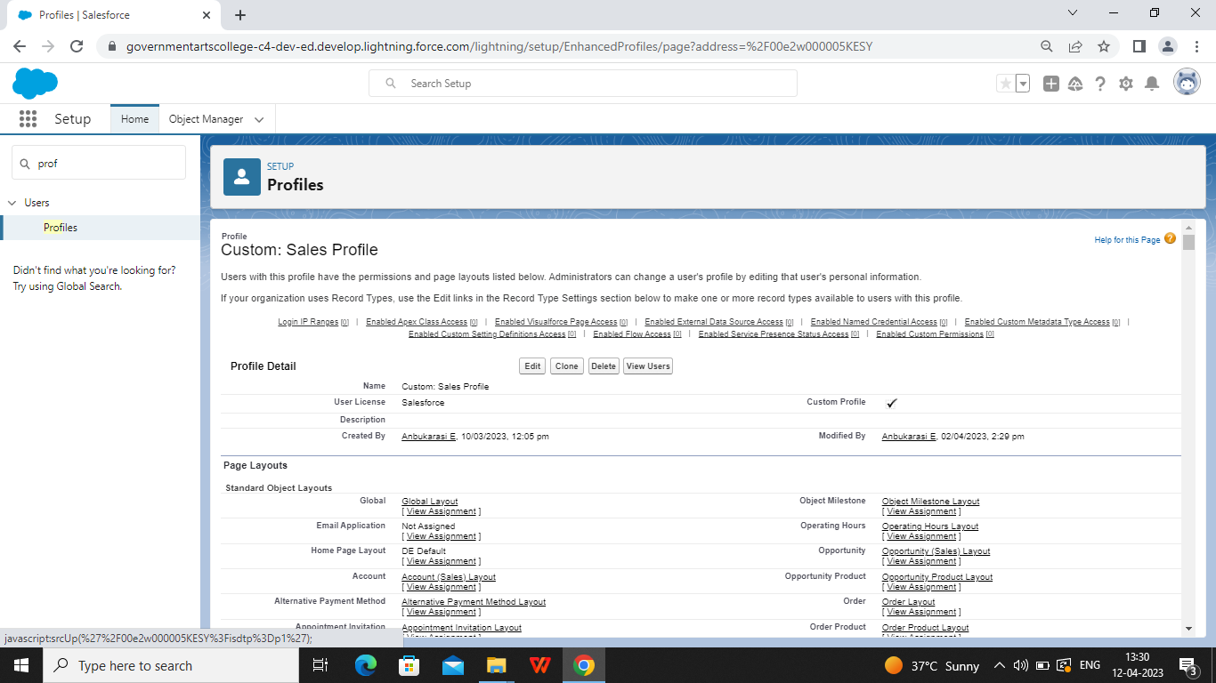

***Milestone 10:***

***Description for User:***

***A user is anyone who logs in to Salesforce . users are employees at your company, such as sales, reps, managers, and IT specialists, who need access to the company records . Every user in Salesforce has a user account.***

***The user account identifies the user, and the user account settings determine what features and the records the users can access.***

***The screenshot are pasted below:***

***Creating a user:***

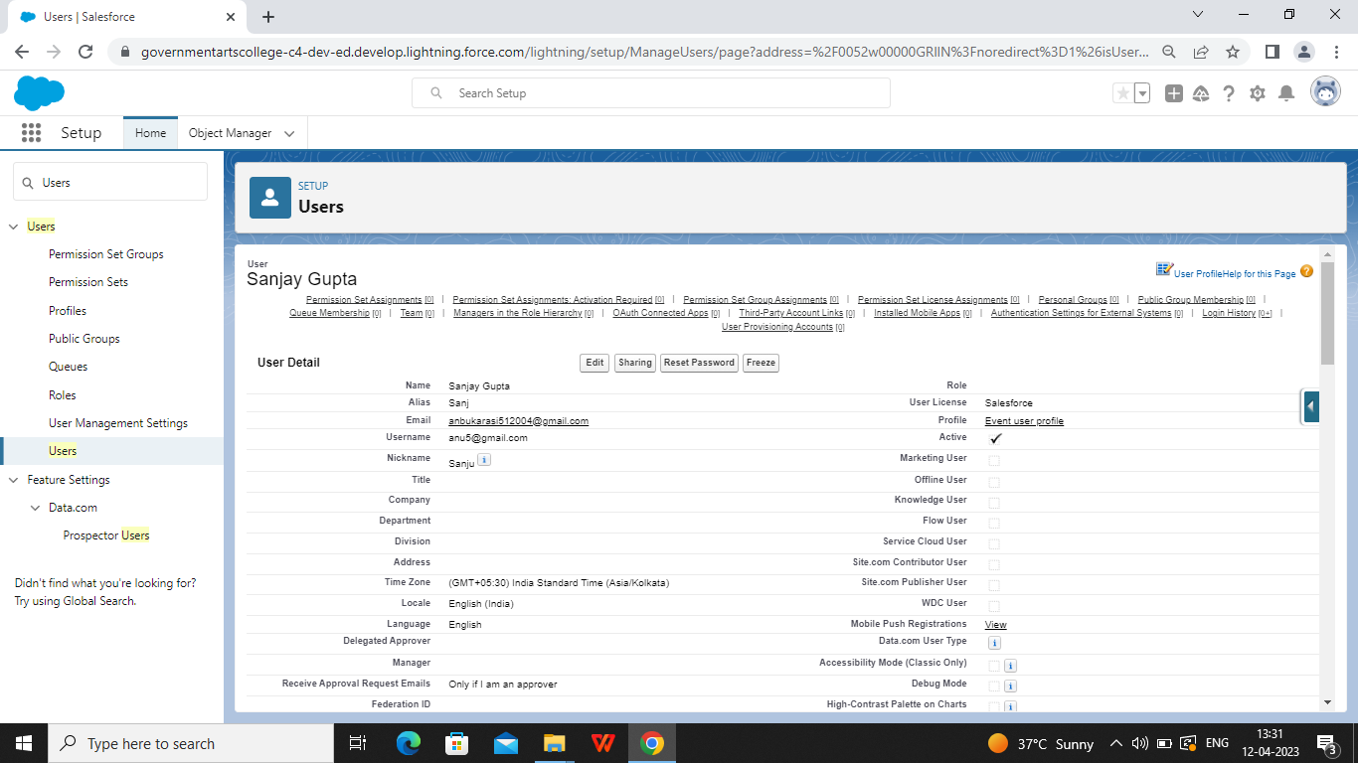

***Creating a user***

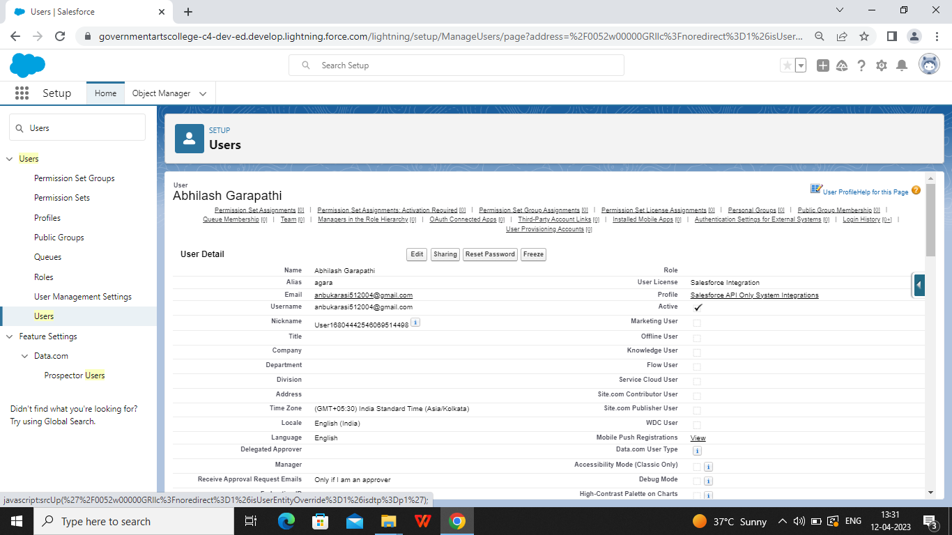

***Milestone 11:***

***Description for Permission set:***

***In Salesforce, a permission set is a collection of settings and permissions that gives users access to various tools and functionally in the platform.***

***Permission sets can be used to grant additional access to users beyond which what is included in their profile, without modifying the profile itself. This allows for granular control over user access and permissions within the Salesforce environment.***

***Permissions sets can be assigned to individual users to a group of users.***

***The screenshot are pasted below:***

***Creating a permission set for Supplier permit:***

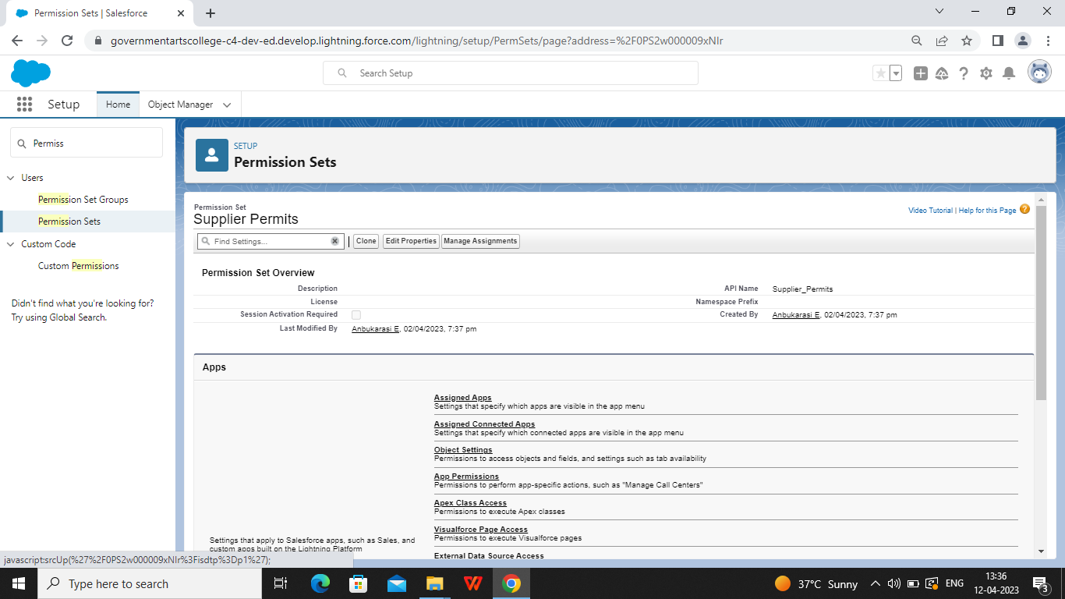

***Creating a permission set for Review object:***

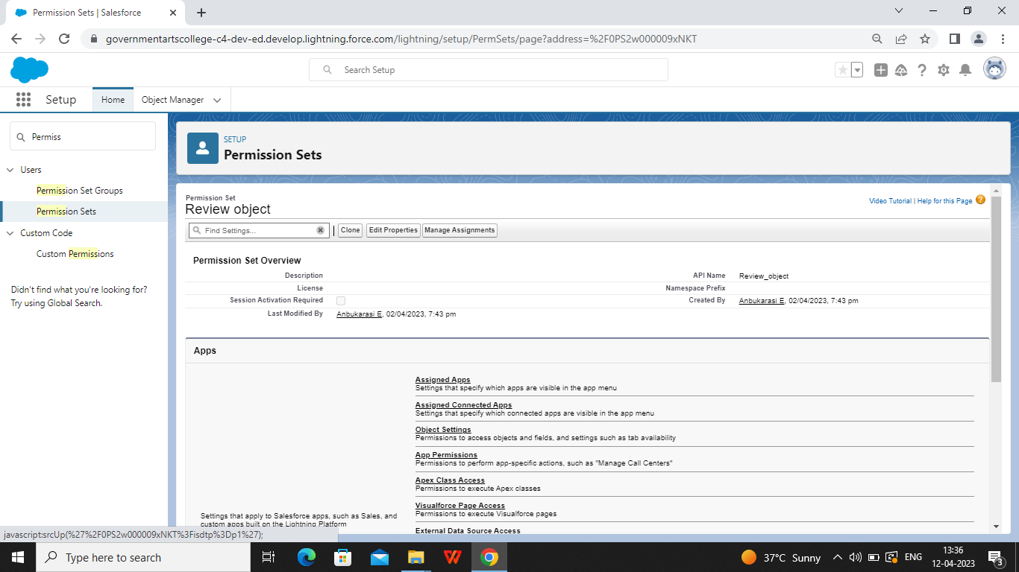

***Milestone 12:***

***Description for Report:***

***A report is a list of records that meet the criteria you define. Its displayed in rows and columns, can be filtered, grouped, or displayed in a graphical chart. Every report is stored in a folder can be public, hidden, or shared, and can be set to read-only or read write.***

***The screenshot are pasted below:***

***Report for Attendees with events:***

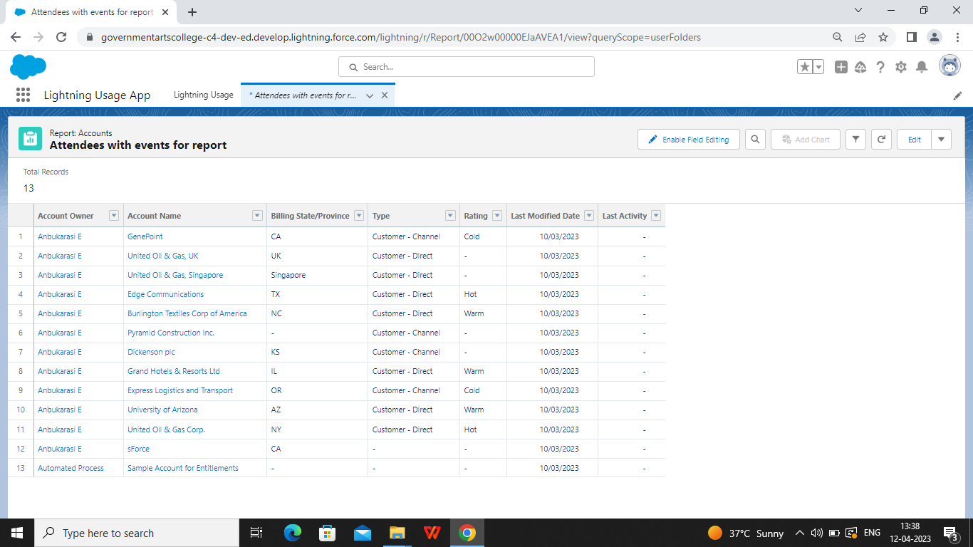

***Report for Job posting objects:***

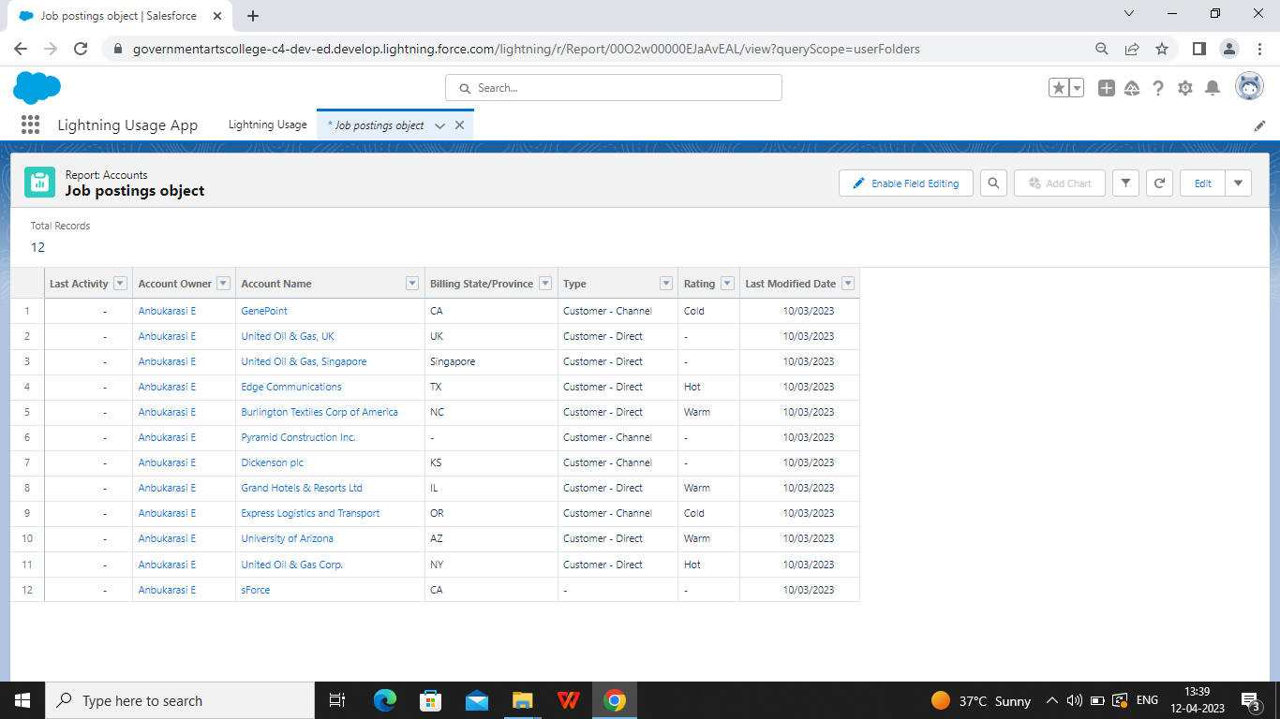

***TRAILHEAD PROFILE PUBLIC URL***

**Team lead – https://trailblazer.me/id/anbue**

**Team Member 1 –https://trailblazer.me/id/sranjini4**

**Team Member 2 -https://trailblazer.me/id/kmathiyazhagan1**

**Team Member 3 -https://trailblazer.me/id/mkandhasamy1**

***ADVANTAGES AND DISADVANTAGES***

***ADVANTAGES***

* ***Advantages for Human Resource Management:***
* ***Human resource planning , Hiring workforce***
* ***Retaining Employees , Enhance organization***
* ***Effectiveness ,Handles disputes and queries***
* ***Motivating Employees, Improves employee relations***
* ***Secure Top talent. Attracting industry-leading talent takes a big commitment.***
* ***Stronger on boarding,Access a big company employee benefits.***

***DISADVANTAGES***

* ***A disadvantages of adding a human resource department is that it requires you to relinquish control regarding how your business operates.***
* ***Other individuals now have the responsibility for making important decisions in key areas, including hiring and personal information.***
* ***Maintains a safe distance***
* ***Hiring competition***
* ***Lower recognition value***
* ***Greater experience expected***
* ***Conflicts of opinion***
* ***Legal liabilities***
* ***Position restrictions***
* ***Costly setup***
* ***Recent origin***

***Unpredictability***

***APPLICATIONS***

***Application of Human resource management :***

* ***Employee self-service portal***
* ***Payroll***
* ***Workforce management***
* ***Recruitment and hiring***
* ***Benefits and administrations***
* ***Talent management***
* ***The computer application in human resource management is the managerial applications of computer use which is usually known as management information system. In case of Human resources management, is known as Human resource information system (HIRS)***

***CONCLUSION***

* ***Human resource management (HRM) consists of an organizations “people practices”***
* ***HRM influences who works for the organization and how those people work***
* ***HR departments have responsibility for a variety of functions related to acquiring and managing employees.***
* ***Training and development is one of the main functions of HRM professionals***
* ***HRM when managed, correctly is a vital part of an organization and its success.***

***FUTURE SCOPE***

* ***The Human resource officer is responsible for providing support in the various human resource functions, which include recruitment, staffing, training and development , performance monitoring and employee counseling.***
* ***Building a healthy work environment and motivating the employee at each step also comes under the scope of human resource management.***
* ***This includes non-monetary amenities like medical,canteen, or other recreational areas.***
* ***A safe and secure work environment plays a huge role in the efficiency of employees.***
* ***HRM is concerned with all aspects of manpower planning, recruitment, selection, placement, induction, transfer, promotion, demotion, training, layoffs, development, retrenchment, wages and salaries.***